**Ideation Phase**

**Define the Problem Statements**

|  |  |
| --- | --- |
| **Date** | 5 November 2022 |
| **Team ID** | PNT2022TMID13490 |
| **Project Name** | Gas leakage monitoring and alerting system for industries |
| **Maximum Marks** | 2 Marks |

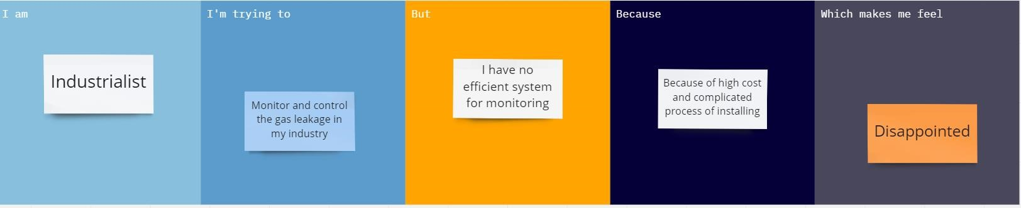

|  |  |  |  |  |  |
| --- | --- | --- | --- | --- | --- |
| **Problem**  **Statement**  **(PS)** | **I am**  **(Customer)** | **I am trying to** | **But** | **Because** | **Which makes me**  **feel** |
| PS-1 | Industrialist | Monitor gas leakage in the industry | I don’t have any system for monitoring | The affordable of the system is high and the systems are sometimes making disasters | Unsafe |
| PS-2 | Industrialist | Control the gas leakage | Also, the installation process is too complicated | The number of sensors is unpredictable and the positioning of equipment is improper | Disastrous |